Extra Credit Option English 3

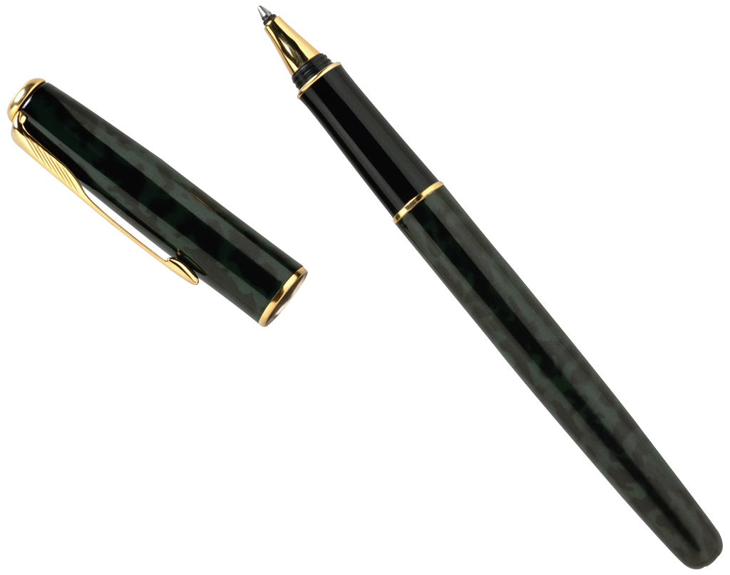

JOURNALISM

1. Write a purely objective "news" account of any of the stories we've read, as though you are a neutral reporter giving only the factual summary of information.

Decide what is most "newsworthy" about the story and come up with a good lead. This may be quite different from the way the short story emphasizes information.

Requirements: Must be a minimum of 1 full page of text, typed, double-spaced, 12 pt font, Times, or Times New Roman style. Make sure to meet all requirements of the prompt/directions above for optimal point value.

2. Imagine that you are the producer or host of a talk show. Pretend that a character from a story we've read is going to be on the show and that everyone in the audience has read he story and is interested in this character.

How would you conduct the interview? What kind of set will you use on your talk show? What questions will you ask the character you will interview?

Requirements: Must be a minimum of 1 full page of text, typed, double-spaced, 12 pt font, Times, or Times New Roman style. . Make sure to meet all requirements of the prompt/directions above for optimal point value.

Extra Credit Points Possible: 5 per piece (limit one of each per semester)

*Remember: you must turn in all work (even if past due and worth only one point now) to be eligible to turn in any extra credit.

