Ms. Costello’s Rules for a Well-Documented, MLA Formatted, Essay or Research Paper

MLA Format: ( see specific formatting here) https://owl.english.purdue.edu/owl/resource/747/01/

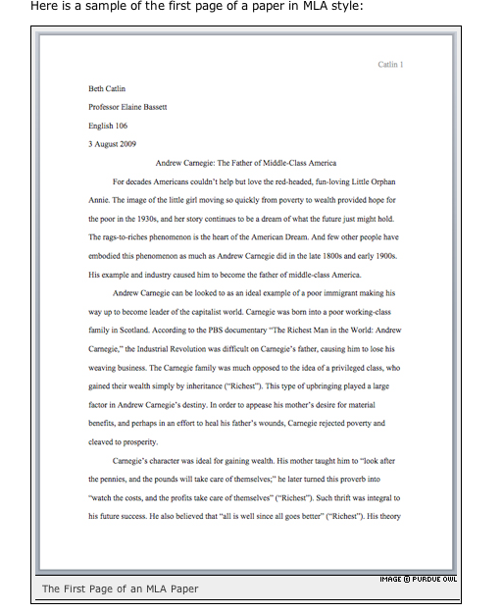

________________________________________________________________
Entire MLA Sample Paper:(see for entire paper)
https://owl.english.purdue.edu/media/pdf/20090701095636_747.pdf
________________________________________________________________
Formatting Direct Quotations within your paper in MLA Style (Parenthetical Documentation DQ):
Here are a list of sites – all helpful and correct:
________________________________________________________________
https://owl.english.purdue.edu/owl/resource/747/03/

Adding or omitting words in quotations

If you add a word or words in a quotation, you should put brackets around the words to indicate that they are not part of the original text.

Jan Harold Brunvand, in an essay on urban legends, states, "some individuals [who retell urban legends] make a point of learning every rumor or tale" (78).
If you omit a word or words from a quotation, you should indicate the deleted word or words by using ellipsis marks, which are three periods ( . . . ) preceded and followed by a space. For example:

In an essay on urban legends, Jan Harold Brunvand notes that "some individuals make a point of learning every recent rumor or tale . . . and in a short time a lively exchange of details occurs" (78).
Please note that brackets are not needed around ellipses unless adding brackets would clarify your use of ellipses.
________________________________________________________________
http://www.nvcc.edu/loudoun/english/writingcenter/online%20writing%20center/quotingsmoothly.htm

Quoting Smoothly

When you quote something, the quotation should become a part of your own sentence--without any seams. Here are some tips for quoting smoothly and correctly:
1. One strategy is to set up the quotation with a sentence of your own, ending that sentence with a colon, followed by the quotation.
George knows that Lennie did not intend to kill Curly's wife. He pleads with the other men not to seek revenge: "The poor bastard's nuts. Don't shoot 'im." (Steinbeck 1451).

2. You can also precede a quotation with a word like "explains," "illustrates," or "continues"--followed by a comma. ("Says" is ambiguous.)
In Frost's 'Mending Wall,' the neighbor asserts, "Good fences make good neighbors" (line 45).

3. You can make a quotation part of your own sentence.
George promises Lennie that they will "have a couple of acres and live off the fatta the land" (Steinbeck 1412).
4. You can’t just throw a quotation into your sentence if it makes the grammar incorrect. For example, you should NOT write this:
Mrs. Macomber tells Wilson that she wants "to see you perform again" (Hemingway 1351).
Instead, you have at least 3 choices:
Mrs. Macomber tells Wilson, "I want so to see you perform again" (Hemingway 1351).
Mrs. Macomber tells Wilson that she wants "to see [him] perform again" (Hemingway 1351).
Mrs. Macomber tells Wilson how impressed she is with his hunting: "I want so to see you perform again" (Hemingway 1351).

5. To make the grammar correct, you will often need to change some parts of speech--like verb tenses or pronouns. Put brackets [ ] around anything you alter. More examples:
Frost's horseman admires the snowfall but presses on because he has "miles to go before [he] sleep[s]" (line 14).
(The text reads, "miles to go before I sleep.")

6. You can omit some words in a quotation by using ellipses. Again, BE SURE you do not change the meaning!
Edna symbolically rejects society's restrictions when she "cast[s]the unpleasant, pricking garments from her, and . . . [stands]naked in the open air" (Chopin 310).
(The text reads, ". . . she cast the unpleasant, pricking garments from her, and for the first time in her life she stood naked in the open air . . . ")

7. When you are quoting something that is in quotes in the text, use single quotation marks to indicate the original ones. Use double ones around your own quotation, as usual.
For Macomber, the buffalo hunt is a rebirth: "Macomber's face was shining. 'You know something did happen to me,' he said. 'I feel absolutely different'" (Hemingway 1365).

(All the citations above come from McMichael's Anthology of American Literature, 3rd edition.)

_______________________________________________________________

http://faculty.mc3.edu/hhalbert/shared/quotes_citations/quotes.htm#ellipses

Using Signal Phrases:

One common error a lot of people make when they include a quote is that they tend to put the quote in a sentence by itself. Unfortunately, we cannot do this because when we do, we are giving the quote without a specific analytical context. We need to use what Diana Hacker calls a signal phrase to introduce the quote and give our readers a context for the quote that explains why we are taking the time to include it in our paper.
Take, for example, this section from a paper on Narrative of the Life of Frederick Douglass, An American Slave, Written by Himself:

We can see Douglass' marriage as an assertion of his ownership of himself. "What Douglass's certificate of marriage, which is transcribed in full in chapter 11, signifies is that the black man has repossessed himself" (Baker 170).

In this example, the quote from an essay by Houston A. Baker, Jr. thrusts itself into the flow of the paper, disturbing readers because there is no warning that the quote is coming. Yet, with a signal phrase, we can make the use of the quote seem more natural to readers:

We can see Douglass' marriage as an assertion of his ownership of himself, as Houston A. Baker, Jr. argues in his essay "The Economic of Douglass's Narrative": "What Douglass's certificate of marriage, which is transcribed in full in chapter 11, signifies is that the black man has repossessed himself" (170).

By including a reference to Baker and his essay in the sentence before giving the quote, we let the reader know that we are using someone's opinion to support our own, giving the quote a context that the reader finds relevant to our overall point.
According to the St. Martin's Guide, there are three main ways to set up a signalling phrase:

1. With a complete sentence followed by a colon.

The effects of Auld's prohibition against teaching Douglass to read were quite profound for Douglass: "It was a new and special revelation" (29).

2. With an incomplete sentence, followed by a comma.

Douglass argues that Auld's prohibition against literacy for him was a profound experience, saying, "It was a new and special revelation" (29).

3. With a statement that ends in that.

The importance of Auld's prohibition to Douglass is clear when he states that "It was a new and special revelation" (29).
You can, however, build your own signal phrases by mixing these three basic styles with verbs that describe your source's attitude towards the subject of the quote. Here is a list of such verbs, as well as other phrases you can use:
admits  agrees  argues  asserts  believes  claims  compares  confirms  contends  declares  denies | emphasizes  insists  notes  observes  points out  reasons  refutes  rejects  reports | responds  replies  suggests  thinks  writes  In _____'s words  According to ____'s (notes, study, narrative, novel, etc.)

________________________________________________________________

http://faculty.mc3.edu/hhalbert/shared/quotes_citations/quotes.htm#name

Using the Source's Name

Generally, the first time we use a source in a paper, whether it be through a paraphrase or a quote, it's a good idea to use the author(s) full name(s) and the title of the source we are using in the actual sentence so that readers feel that we have introduced the source to them. After we have introduced the source, it's perfectly acceptable to refer to the author by his or her last name or even to leave the name out of the body of our text and simply include it in the citation.

First use:
In his Narrative of the Life of Frederick Douglass, An American Slave, Written by Himself, Frederick Douglass argues that "Slavery proved as injurious [to slave holders] as it did to me" (31).

Second use:
Douglass earlier argues that slavery was "a fatal poison of irresponsible power" to slave holders (29).

Third use:
The use of the word "hypocrites!" suggests that even the religious faith of the slave holders was tainted by their ownership of other humans (Douglass 77).

When we do refer to authors by name, we should omit words such as "Mr.," "Mrs.," "Ms.," and especially "Miss." These words aren't necessary and seem condescending in certain cases.
_________________________________________________________

http://faculty.mc3.edu/hhalbert/shared/quotes_citations/quotes.htm#paraphrase

When to Paraphrase vs. When to Quote:
When we quote a passage, we do so in order to analyze how a specific effect works in the text. If there is no clear effect that we wish to discuss, we may want to simply paraphrase the key incidents or details of a passage so as to avoid slowing down our own writing with the words of someone else.
We need to be careful when we paraphrase, though. We have to create a sentence that uses a different sentence structure and language. If our paraphrase contains elements that are a word-for-word match to the source text or so close that it is difficult to tell the difference, we could be charged with plagiarism because it looks like we are trying to steal the words or ideas of someone else. In the case of word-for-word paraphrasing, rewrite it or turn it into a direct quote. In the case of a near quote, give a citation for the sentence as if it was a direct quote, just to be safe.
_____________________________________________________
http://faculty.mc3.edu/hhalbert/shared/quotes_citations/quotes.htm#punctuating

